ProjectC: Better Lights and Materials

Wenjie Zhang (netID: wzm416)

Goal: To have different sources lights and attain multiple lighting effects

User’s Guide:

<1> Use Up/Down/Right/Left Arrows to move up/down/right/left.

<2> Use W and S to look up and down.

<3> Use R/F/T/G/Y/H to change color.

<4> Use Z to switch Phong Shading and Gouraud Shading.

<5> Use U/J/I/K/O/L to move light.

<6> Use Space to swith Blin-Phong Lighting and Phong Lighting.

Result Pictures:

Observing from long distance:

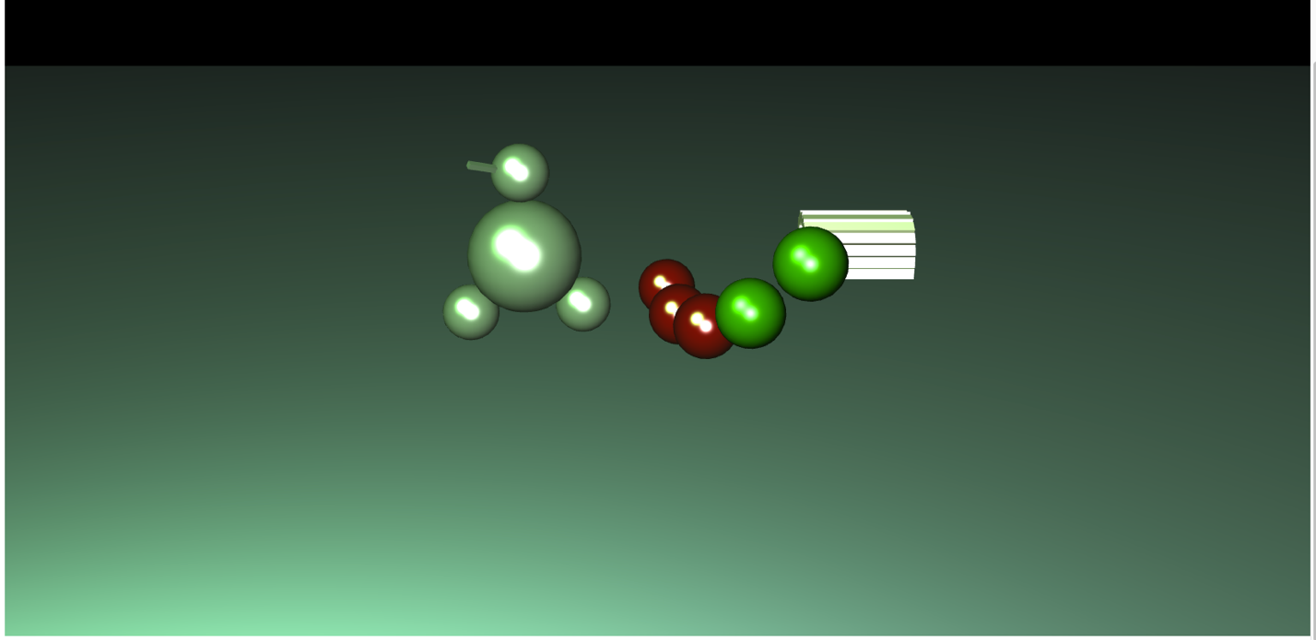

Observing from Short distance:

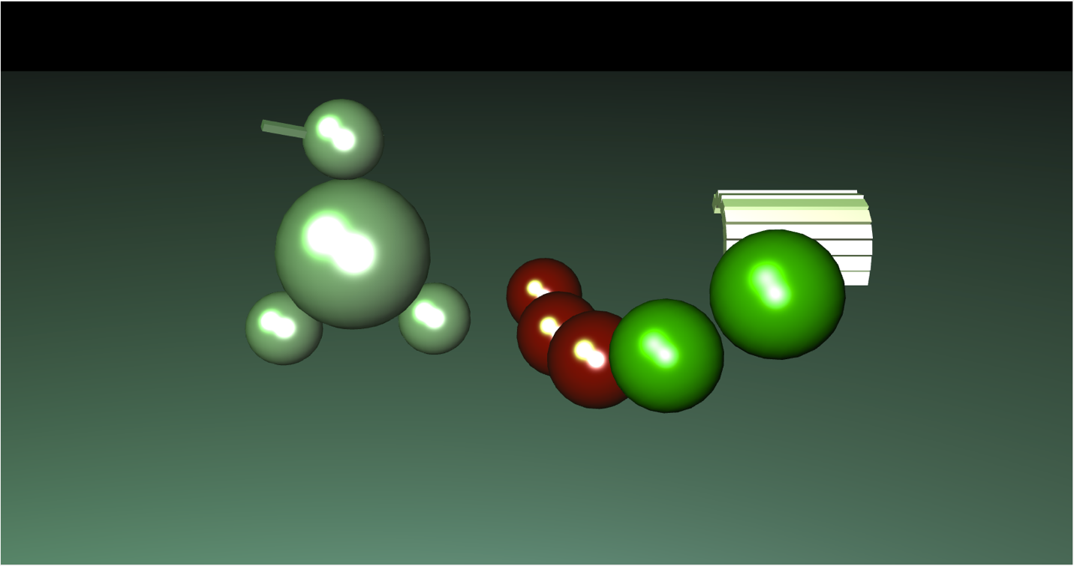

Observing from Left distance:

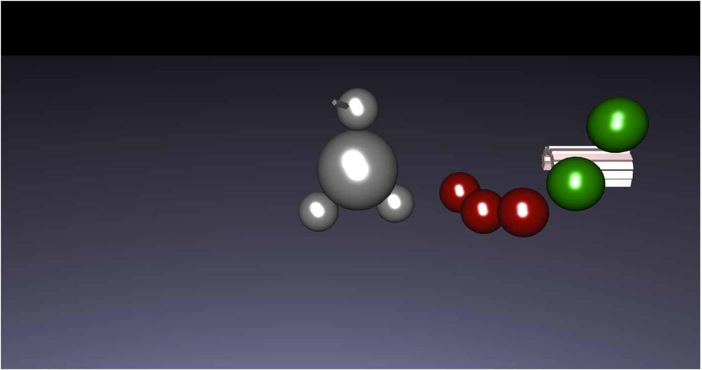

Observing from Right distance:

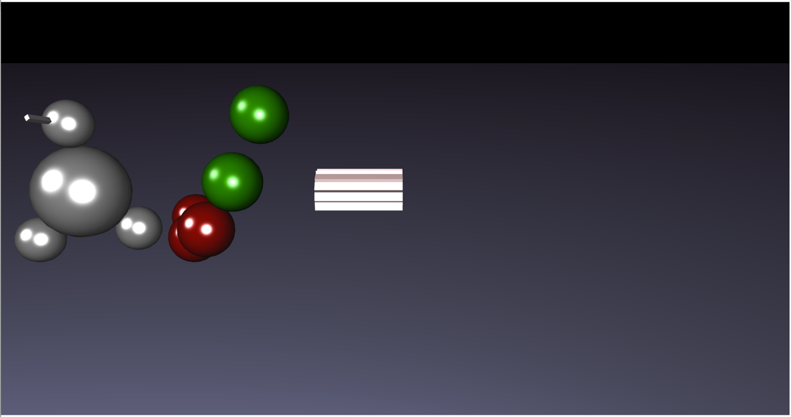

Color Change:

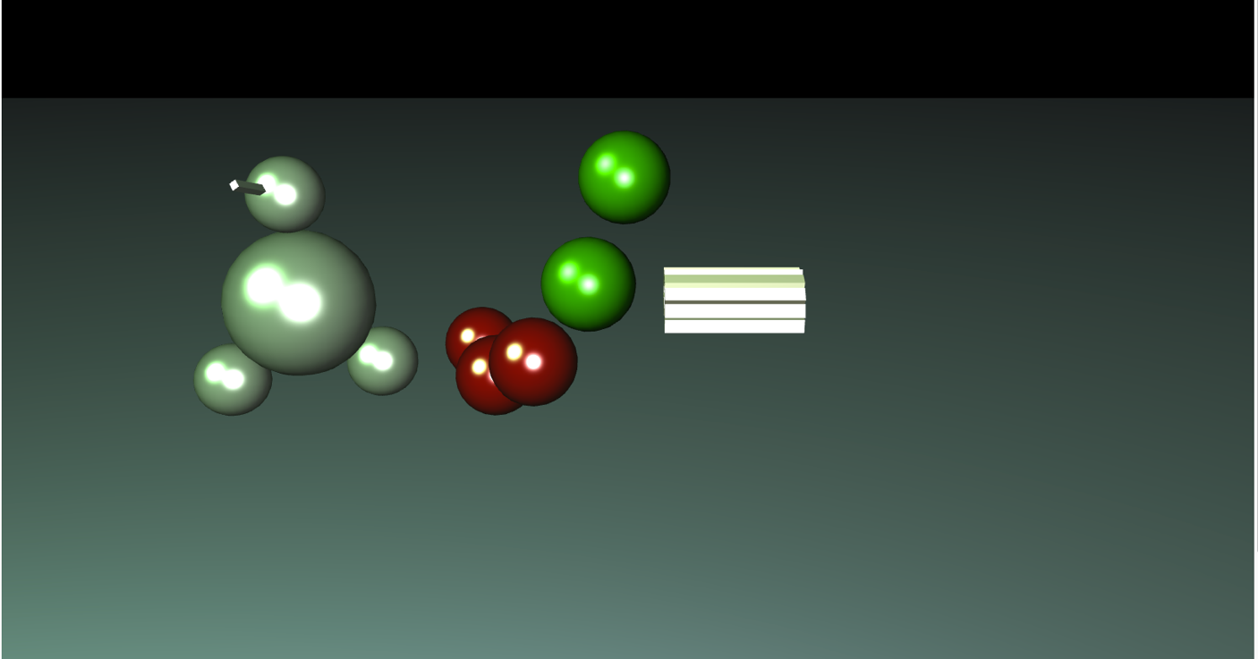

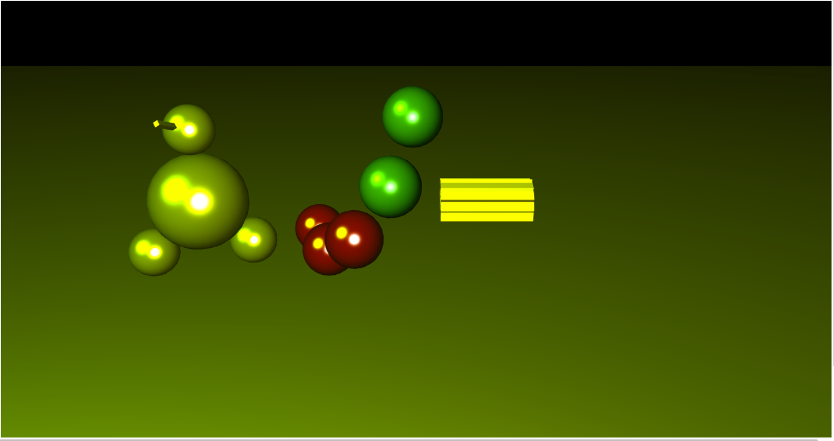

Gouraud Shading + Blin-Phong Lighting:

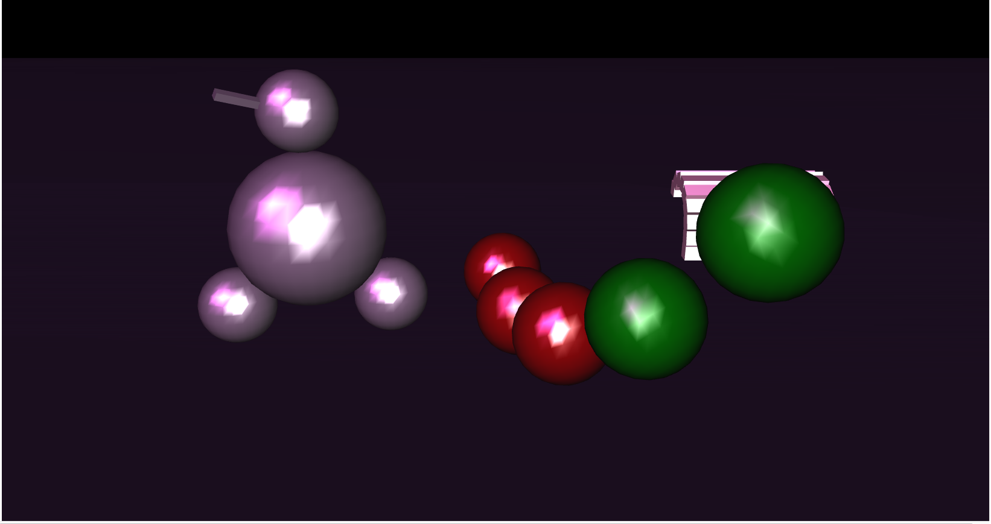

Gouraud Shading +Phong Lighting:

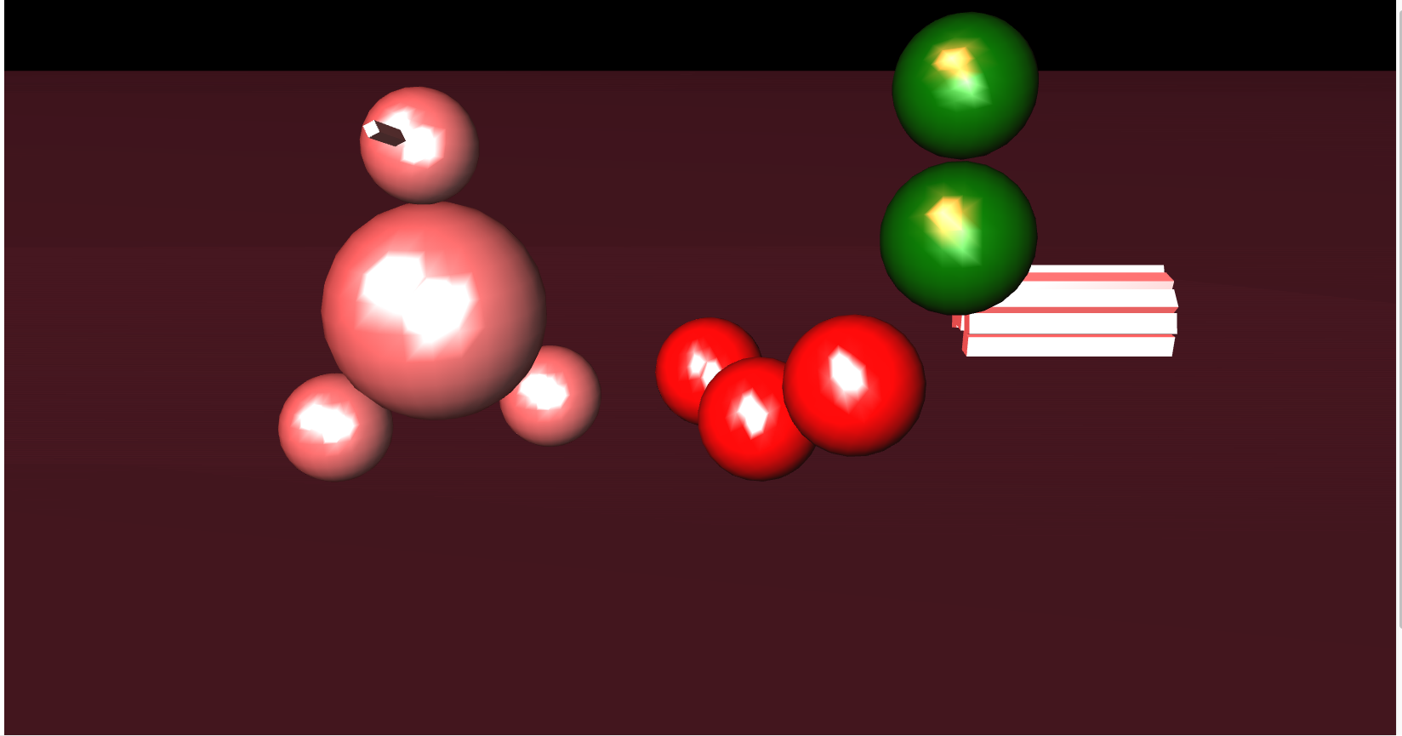

Phong Shading + Blin-Phong Lighting:

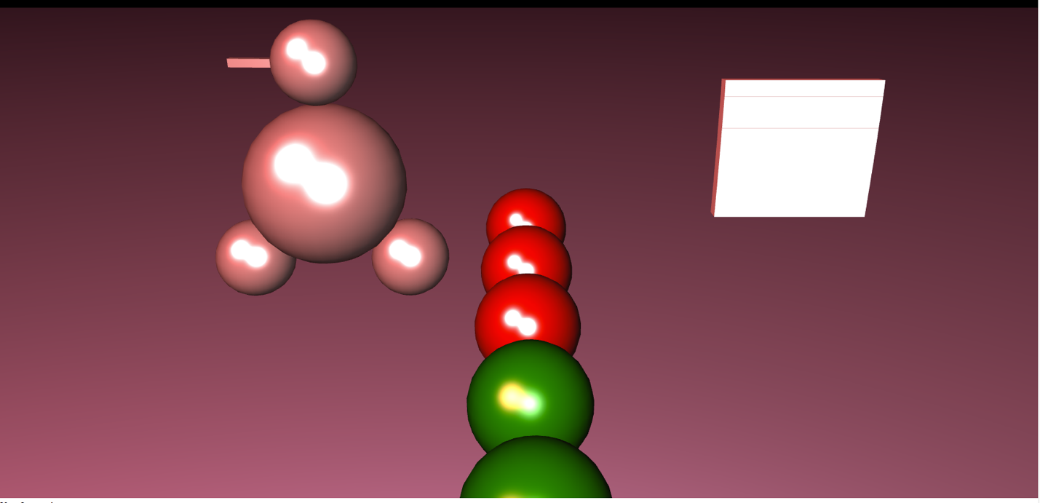

Phong Shading + Phong Lighting:

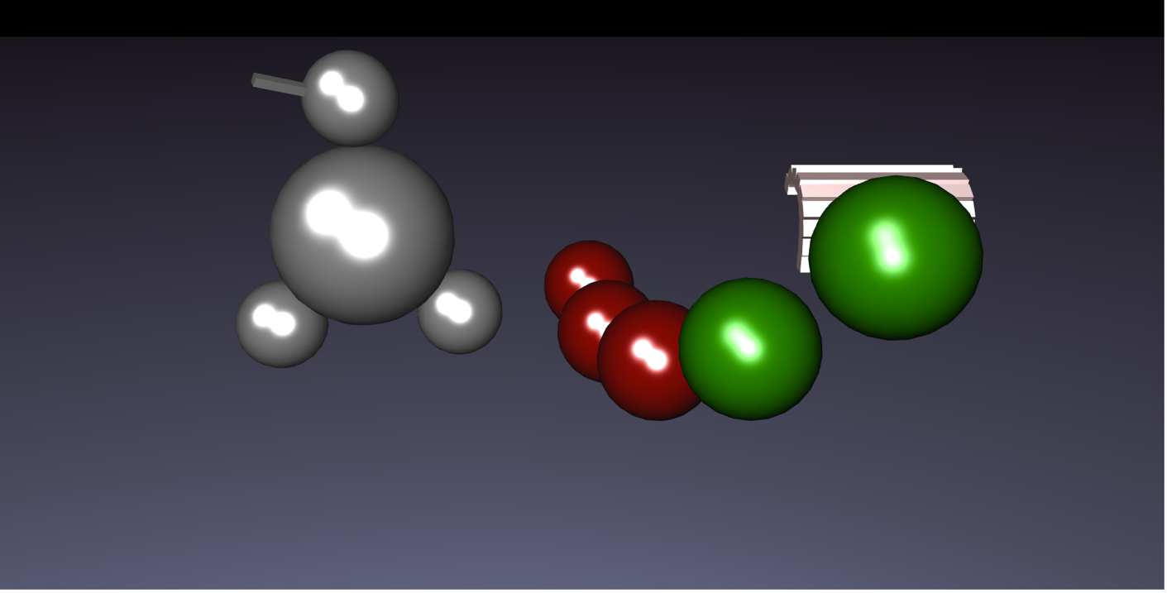

Lighting direction change:

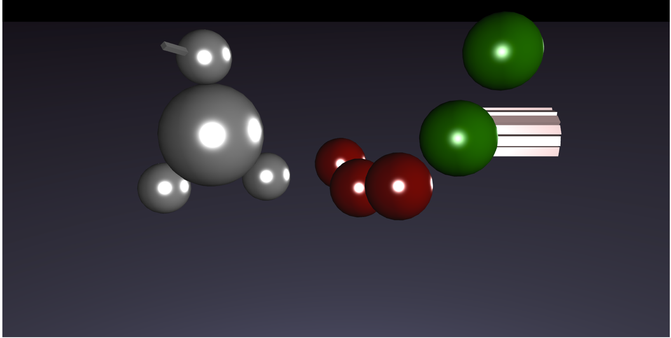

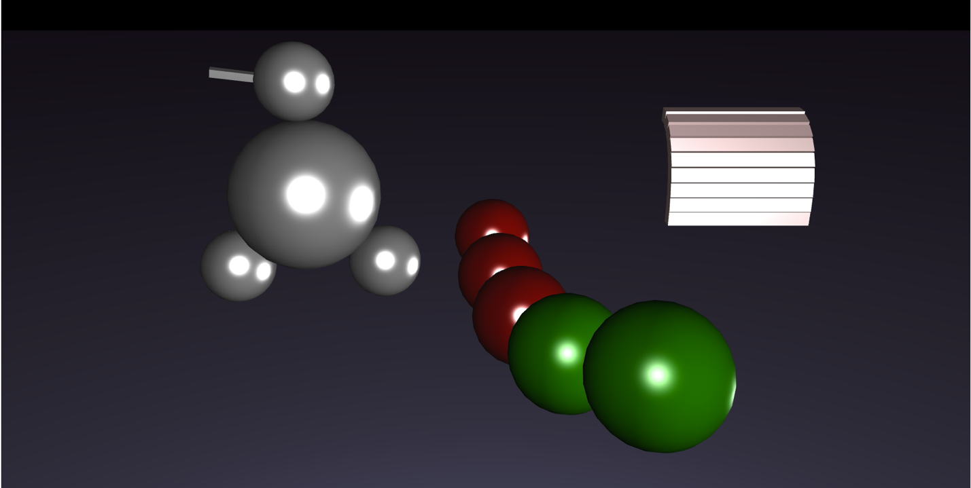

Scene Graphs:

